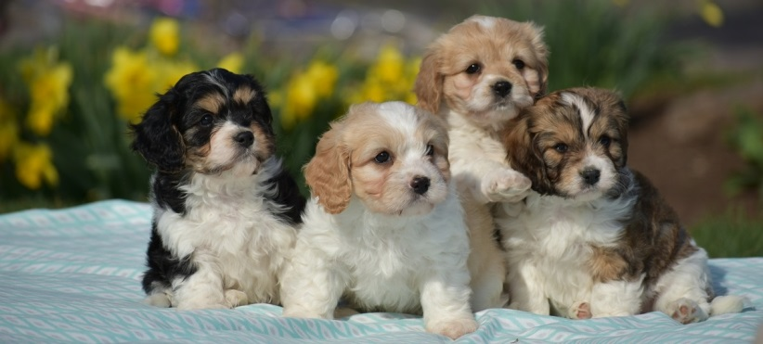
Pond View Puppies
Please contact us at 570-644-1932
Congratulations on your new puppy! We want to take the opportunity to thank you for purchasing a puppy from the Riehl family! We take pride in providing quality puppies for you, our customer! We expect your puppy to get the same excellent care in its new home just like it has in ours.
We understand that welcoming a new puppy into your home can be hectic at times and we are here to assist you in any way we can. To help with this process, we have compiled a list of some helpful tips to make your pup’s transition into his new home as smooth as possible.
*Prepare a comfortable place for your puppy to nest and sleep. A crate will provide a den-like feel for your puppy.
*Immediately after your puppy wakes up from a nap, take him outside to go potty.
*Reward your puppy for going potty outside by praising it profusely or giving it a small treat.
*Always take your puppy outside as soon as it has finished a meal and right before it goes to bed.
*Play with your puppy in the evenings so your puppy is tired when you are ready for bed.
*While your puppy is small, expect its schedule to be 45 minutes to an hour of playtime and eating, then sleeping for 2 hours during the daytime. During the night, you should take the pup out around 2PM until your pup learns to sleep thru the night.
*Make sure your pup goes outside for exercise 2 or 3 times a day. While the pup is small, walks should be limited to 10 minutes. Walking time can increase gradually, but absolutely no strenuous walking until the puppy is over 2 years old.

Selecting the right dog food for your puppy can be difficult since there are so many to choose from. We recommend a high quality food, a food that is not made from a lot of “filler”. Your puppy has been eating Plantation dog food. Unfortunately, Plantation is not available in any chain stores or online. However, you can text the Plantation dealer at 570-316-2718 to have some food shipped to you. A 30 LB bag of plantation puppy food costs $68, shipping and tax included. You can also ask to buy a bag when you pick up your puppy. If you go with a brand that you can pick up in a pet store, we suggest Eukanuba. Choosing a food with the right amount of vitamins, minerals, whole grains, protein, fibers, and crude fat is vital to the health of your puppy. We recommend a high protein diet with no less than 40% of the food being protein and fat combined. It is also important to make sure the food your buy does not contain more than 50% of filler content. In the dog food analysis, the food should contain over 50% of protein, fat, fiber, and moisture.
Toys are also an important part of the adoption process. When choosing size-appropriate toys, be sure to avoid toys that could potentially cause swallowing or choking hazards to your pet. Your puppy will need some chewing toys during its teething process, please stay away from tennis ball style toys, raw hide bones, and nylabones. Providing your puppy with brain stimulating toys and plenty of exercise will keep them from chewing on household objects and furniture.

